

Model-Driven Conceptual Design

System Design and Management School

西村研究室

Shared bicycles that also share energy

Author: Hiroyasu Ishikawa

Revision: 03

|  |  |
| --- | --- |
|  |  |
|  | Date: November 07, 2022 |

# Model Introduction

**Model** **Specification>Documentation**

Author: Hiroyasu Ishikawa

Created:4/17/17 4:29 PM.

Title: Shared bicycle also share energy

This model shows a new bicycle and its energy sharing service.

The most core idea of this service is to solve the issues of existing bicycle sharing services by sharing not only bicycles but also energy.

In the future, the service could be expanded to a small energy sharing service that distributes small amounts of energy, like a small mobility service for the elderly.

# All Project Diagrams

## Bicycle-energy-sharing Concept

**Diagram Specification>Documentation**

**In:** Concept Model.Bicycle-energy-sharing Concept.Bicycle-energy-sharing Concept

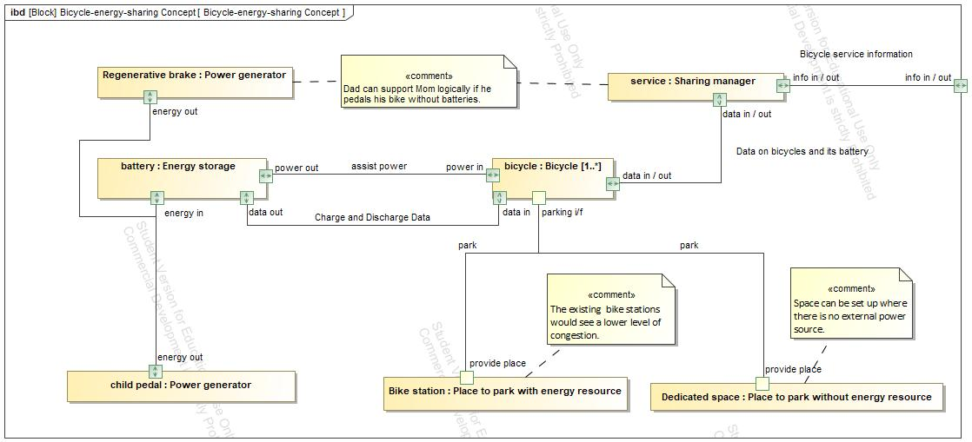

1. Diagram Bicycle-energy-sharing Concept

## Product Use Case Diagram

**Diagram Specification>Documentation**

**In:** Concept Model.Product Use Case Diagram

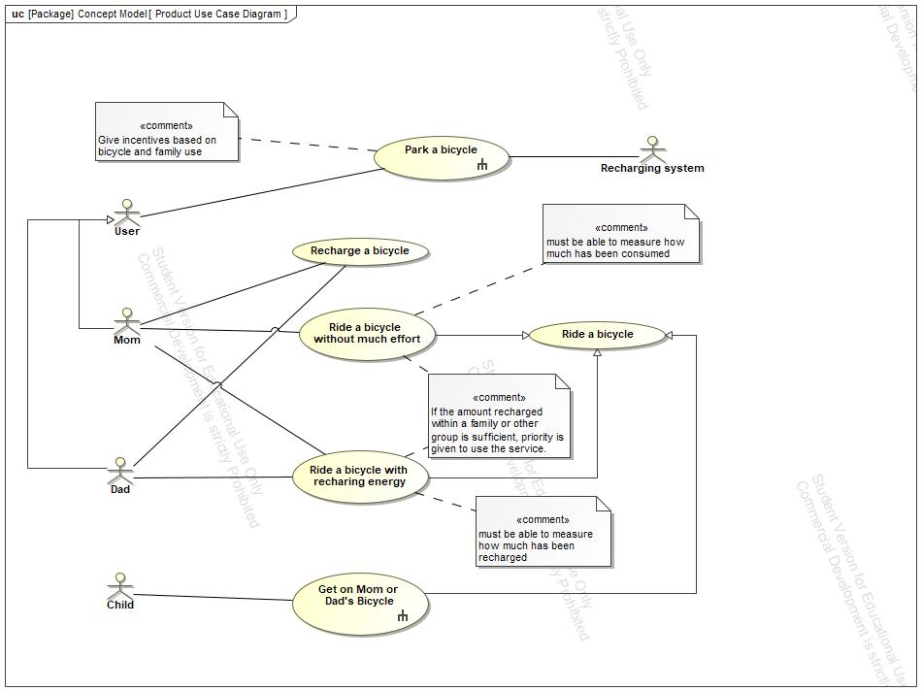

1. Diagram Product Use Case Diagram

## Mapping Concept to PoC

**Diagram Specification>Documentation**

**In:** Proof of Concepts.Procurement PoC1.Mapping Concept to PoC

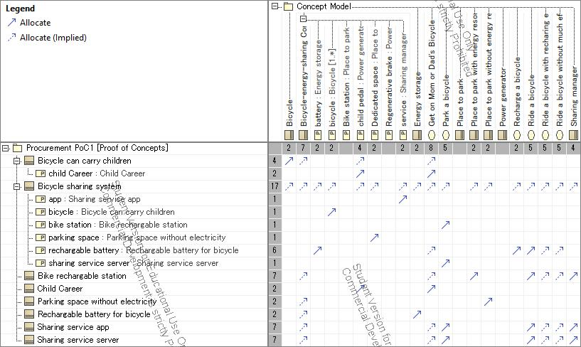

1. Diagram Mapping Concept to PoC

## Ideas and Assumption Diagram

**Diagram Specification>Documentation**

**In:** Concept Model.Data.Ideas and Assumption Diagram

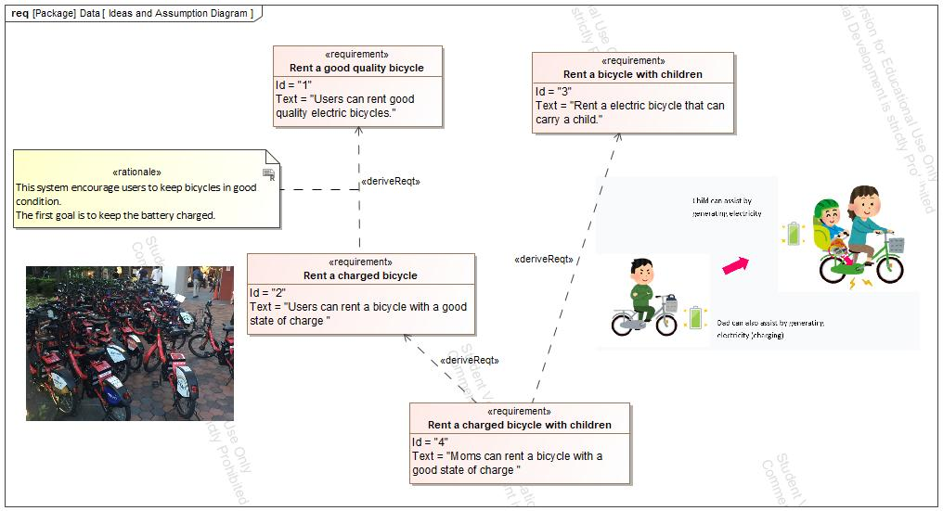

1. Diagram Ideas and Assumption Diagram

## PoC Blocks

**Diagram Specification>Documentation**

**In:** Proof of Concepts.Procurement PoC1.PoC Blocks

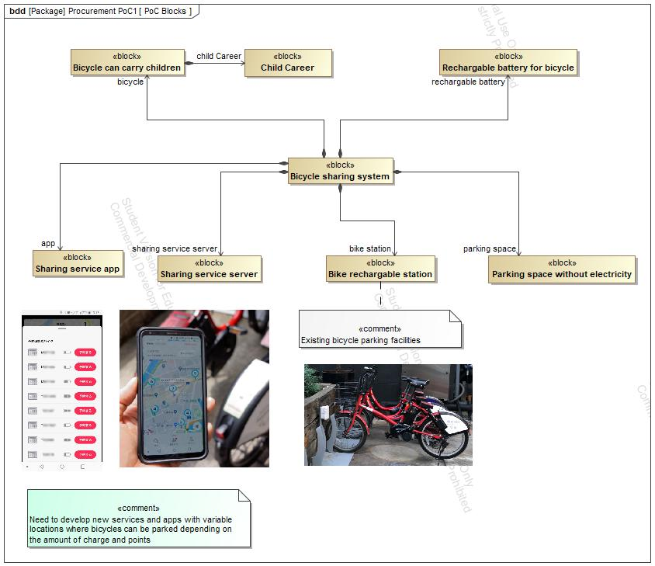

1. Diagram PoC Blocks

## Get on Mom or Dad's Bicycle

**Diagram Specification>Documentation**

**In:** Concept Model.Get on Mom or Dad's Bicycle.Get on Mom or Dad's Bicycle.Get on Mom or Dad's Bicycle

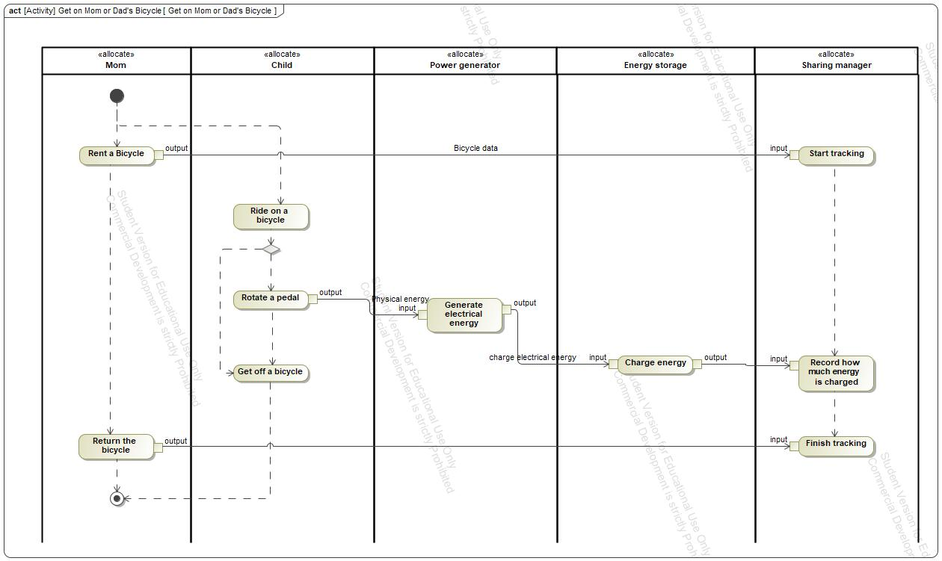

1. Diagram Get on Mom or Dad's Bicycle

## Concept Model

**Diagram Specification>Documentation**

**In:** Concept Model.Concept Model

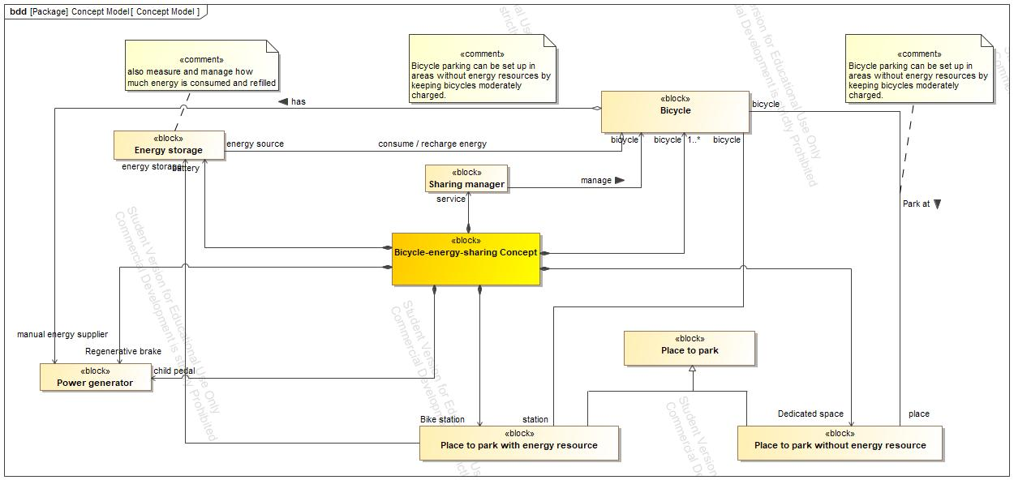

1. Diagram Concept Model

## Bicycle sharing system

**Diagram Specification>Documentation**

**In:** Proof of Concepts.Procurement PoC1.Bicycle sharing system.Bicycle sharing system

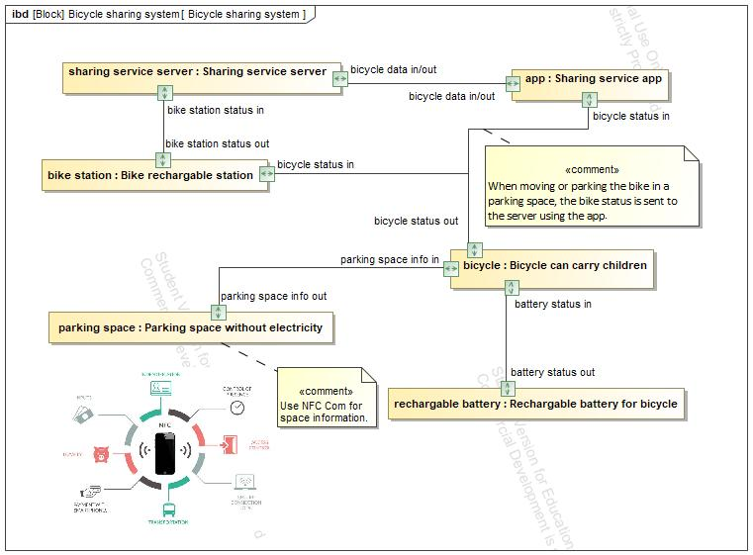

1. Diagram Bicycle sharing system

## Park a bicycle

**Diagram Specification>Documentation**

**In:** Concept Model.Park a bicycle.Park a bicycle.Park a bicycle

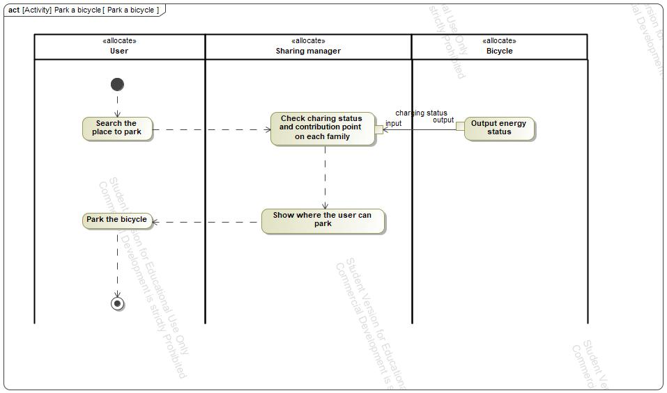

1. Diagram Park a bicycle

# Concept Use-Cases

|  |
| --- |
| **UseCase** |
| Get on Mom or Dad's Bicycle |
| Park a bicycle |
| Recharge a bicycle |
| Ride a bicycle |
| Ride a bicycle with recharing energy |
| Ride a bicycle without much effort |

## Actor Summary

|  |  |
| --- | --- |
| **Primary Actor** | **Use Cases** |
| Child | * Get on Mom or Dad's Bicycle |
| Dad | * Recharge a bicycle      * Ride a bicycle with recharing energy |
| Mom | * Recharge a bicycle      * Ride a bicycle with recharing energy      * Ride a bicycle without much effort |
| Recharging system | * Park a bicycle |
| User | * Park a bicycle |

## Use Case: Product Use Case Diagram Diagram



## Get on Mom or Dad's Bicycle Use Case

|  |  |  |  |
| --- | --- | --- | --- |
| **Use Case Name** | Get on Mom or Dad's Bicycle | ID |  |
| **Complexity** | Average Complexity | | |
| **Description** | The child can supply energy by pedaling at the same time as riding the parent's bicycle. | | |
| **Actors** | * Child | | |
| **Goal** |  | | |
| **Assumption** | No assumption for this use case. | | |
| **Non Functional Requirements** | No non-functional requirement for this use case. | | |

|  |  |
| --- | --- |
| **Relations** | |
| **Association** | * Child Actor |
| **Generalization** | * Ride a bicycle UseCase |

## Park a bicycle Use Case

|  |  |  |  |
| --- | --- | --- | --- |
| **Use Case Name** | Park a bicycle | ID |  |
| **Complexity** | Average Complexity | | |
| **Description** | The user can park bicycles where there are no facilities to supply energy. | | |
| **Actors** | * Recharging system * User | | |
| **Goal** |  | | |
| **Assumption** | No assumption for this use case. | | |
| **Non Functional Requirements** | No non-functional requirement for this use case. | | |

|  |  |
| --- | --- |
| **Relations** | |
| **Association** | * Recharging system Actor * User Actor |
| **Generalization** |  |

## Recharge a bicycle Use Case

|  |  |  |  |
| --- | --- | --- | --- |
| **Use Case Name** | Recharge a bicycle | ID |  |
| **Complexity** | Average Complexity | | |
| **Description** | The user charges energy without moving the bicycle. | | |
| **Actors** | * Dad * Mom | | |
| **Goal** |  | | |
| **Assumption** | No assumption for this use case. | | |
| **Non Functional Requirements** | No non-functional requirement for this use case. | | |

|  |  |
| --- | --- |
| **Relations** | |
| **Association** | * Dad Actor * Mom Actor |
| **Generalization** |  |

## Ride a bicycle Use Case

|  |  |  |  |
| --- | --- | --- | --- |
| **Use Case Name** | Ride a bicycle | ID |  |
| **Complexity** | Average Complexity | | |
| **Description** |  | | |
| **Actors** | See parent class for actor associations | | |
| **Goal** |  | | |
| **Assumption** | No assumption for this use case. | | |
| **Non Functional Requirements** | No non-functional requirement for this use case. | | |

|  |  |
| --- | --- |
| **Relations** | |
| **Association** | No direct association to this use case. Check the parent use case (see Generalization below.) |
| **Generalization** |  |

## Ride a bicycle with recharing energy Use Case

|  |  |  |  |
| --- | --- | --- | --- |
| **Use Case Name** | Ride a bicycle with recharing energy | ID |  |
| **Complexity** | Average Complexity | | |
| **Description** | The user can ride a bike with charging energy, can also ride without charging. | | |
| **Actors** | * Dad * Mom | | |
| **Goal** |  | | |
| **Assumption** | No assumption for this use case. | | |
| **Non Functional Requirements** | No non-functional requirement for this use case. | | |

|  |  |
| --- | --- |
| **Relations** | |
| **Association** | * Dad Actor * Mom Actor |
| **Generalization** | * Ride a bicycle UseCase |

## Ride a bicycle without much effort Use Case

|  |  |  |  |
| --- | --- | --- | --- |
| **Use Case Name** | Ride a bicycle without much effort | ID |  |
| **Complexity** | Average Complexity | | |
| **Description** | Ride a bicycle without much effort using the charged energy. | | |
| **Actors** | * Mom | | |
| **Goal** |  | | |
| **Assumption** | No assumption for this use case. | | |
| **Non Functional Requirements** | No non-functional requirement for this use case. | | |

|  |  |
| --- | --- |
| **Relations** | |
| **Association** | * Mom Actor |
| **Generalization** | * Ride a bicycle UseCase |